**Lab Exercise 4- Signed Commits in Git and GitHub**

**Objective:**  
To configure Git to sign commits with GPG, push them to GitHub, and verify commit authenticity for secure code contribution.

**Prerequisites:**

* Git installed on your system
* GPG (GNU Privacy Guard) installed and configured
* GitHub account with a repository (you own or have write access to)
* Basic knowledge of Git commands
* **Step 1 – Generate or Use an Existing GPG Key**

1. **Check for existing keys**

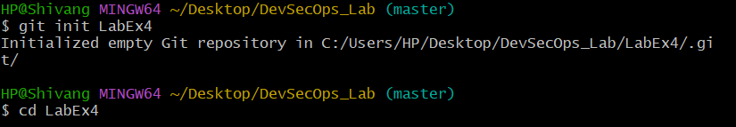



1. **If no key exists, generate a new one**
   * Select **RSA and RSA**
   * Key size: **4096**
   * Expiration: **0** (never) or a fixed date
   * Enter your **GitHub-registered name and email**

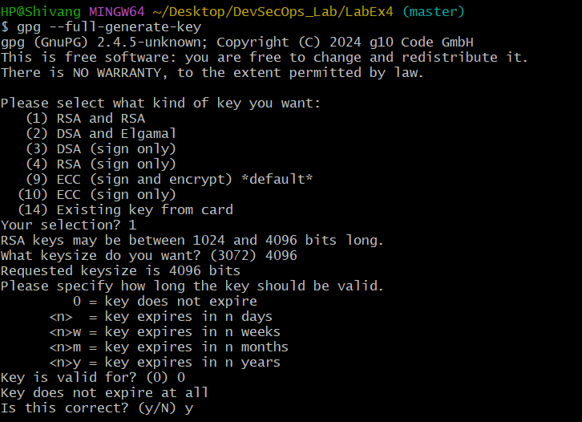

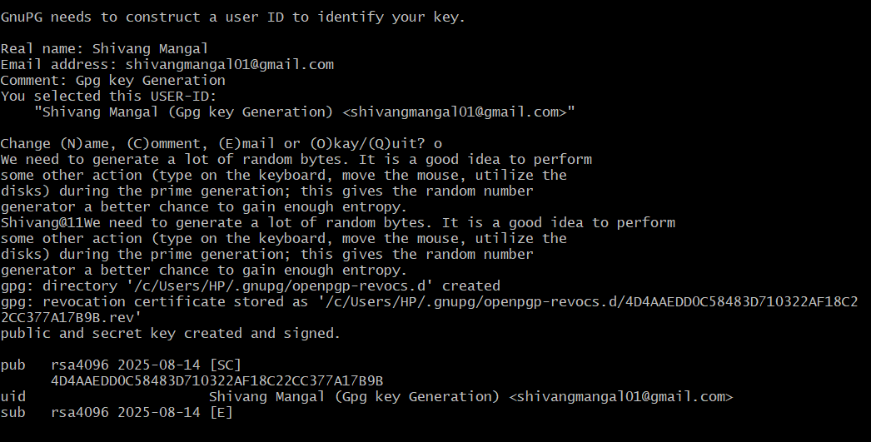

1. **Get your key ID**

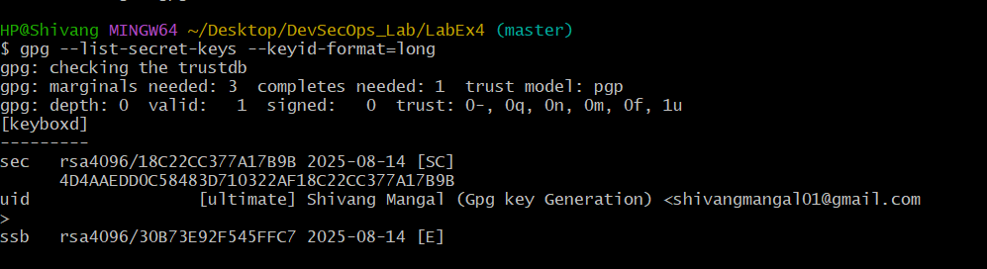

* **Step 2 – Add GPG Key to GitHub**

1. **Export your public key.**
2. **Copy the output.**
3. **Go to GitHub → Settings → SSH and GPG Keys → New GPG Key.**
4. **Paste your key and save.**

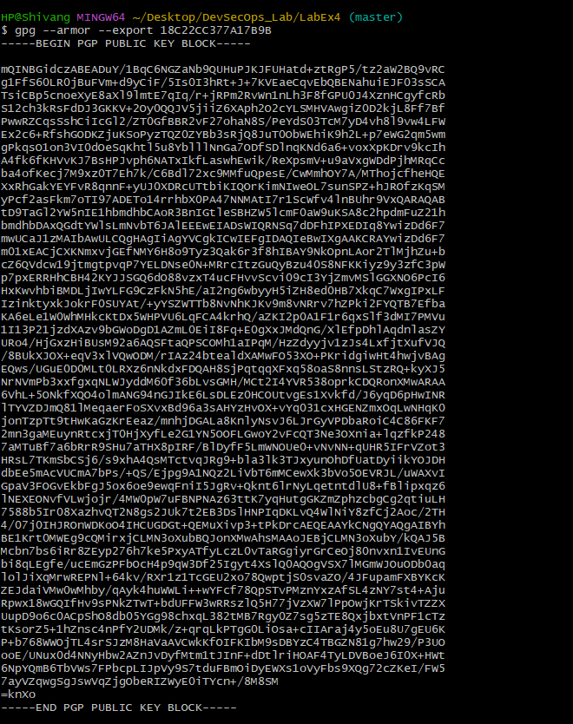



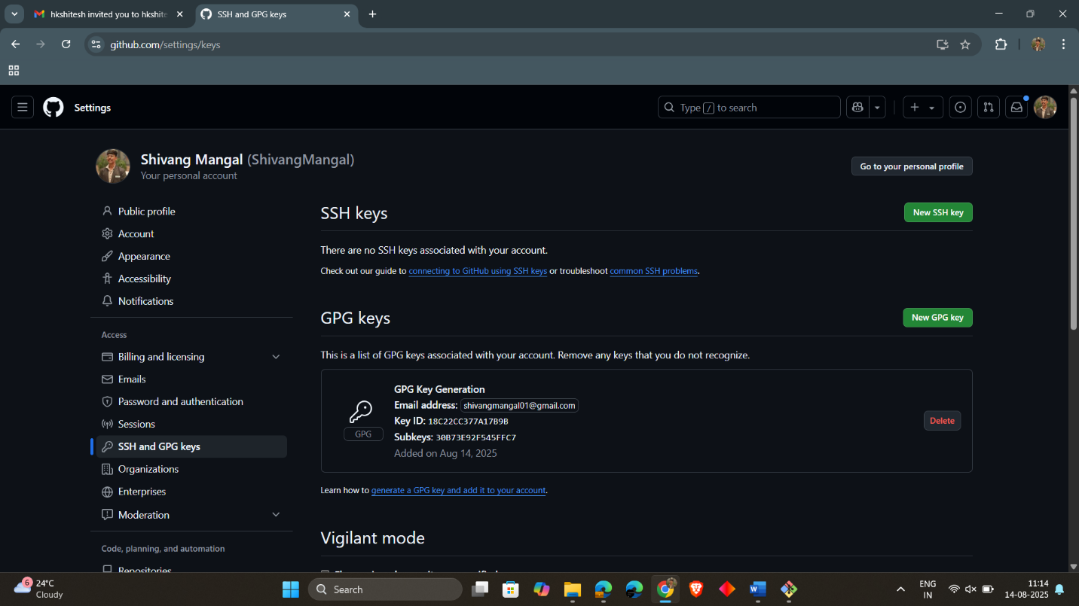

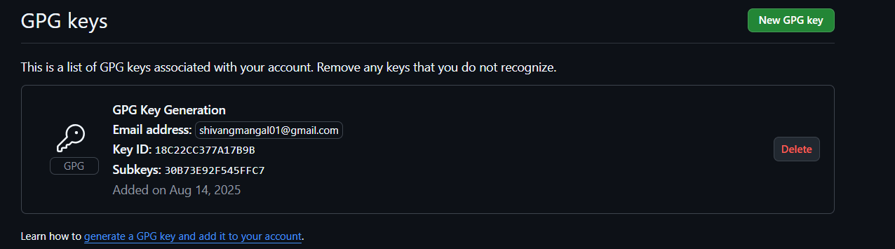

* **Step 3 – Configure Git for Signed Commits**

1. **Tell Git which key to use**
2. **Enable signing for all commits**

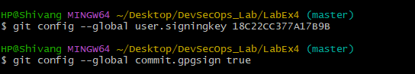

* **Step 4 – Make a Signed Commit**

1. **Clone your repo (or use an existing one)**
2. **Edit or create a file**
3. **Commit with signing**
4. **Enter your GPG passphrase when prompted.**

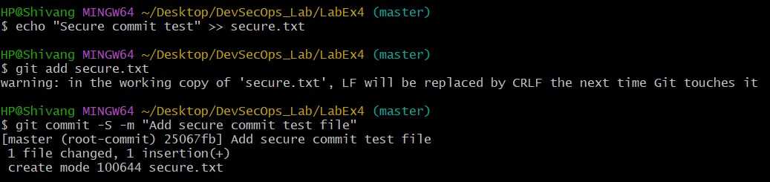

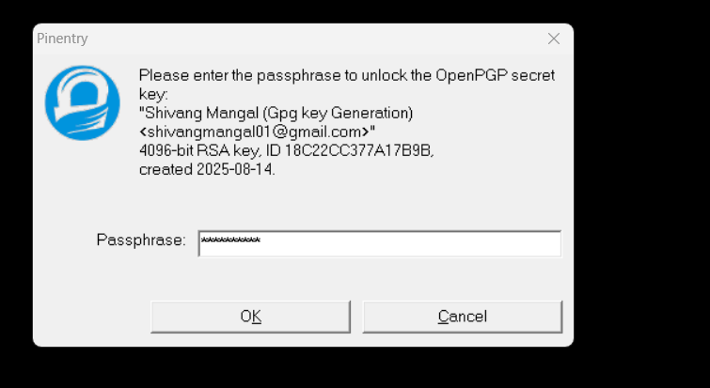

* **Step 5 – Push and verify on GitHub**

1. **Push the commit:**
2. **Go to your repository on GitHub → Click the commit → You should see a green “Verified” badge.**

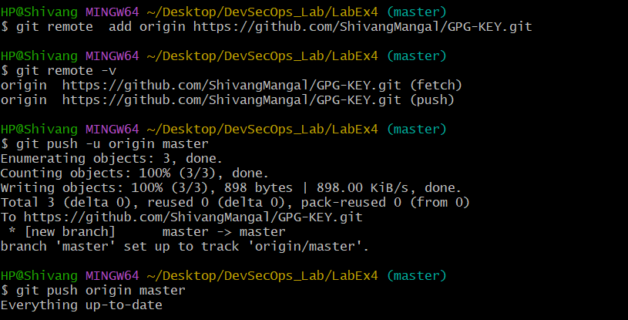

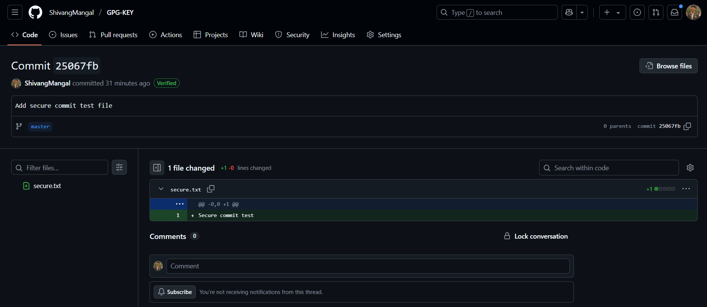

* **Step 6 – Local Verification of Commit**

This will display the GPG verification details locally.

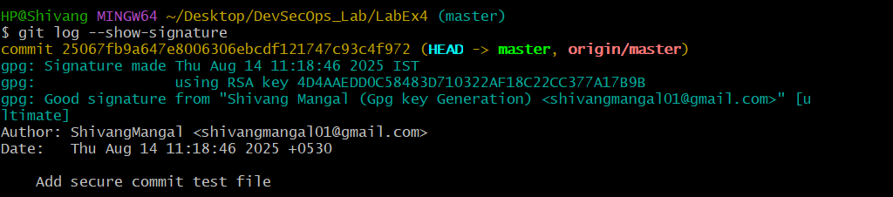

**Use Case: -**

Signed commits prevent identity spoofing in collaborative projects, ensuring only verified authors can make trusted changes in critical codebases.